Activity: Link
Content
Content will vary by school availability. The following are screenshots of how various availabilities may look:
- Park City West (Desktop, tablet): Link
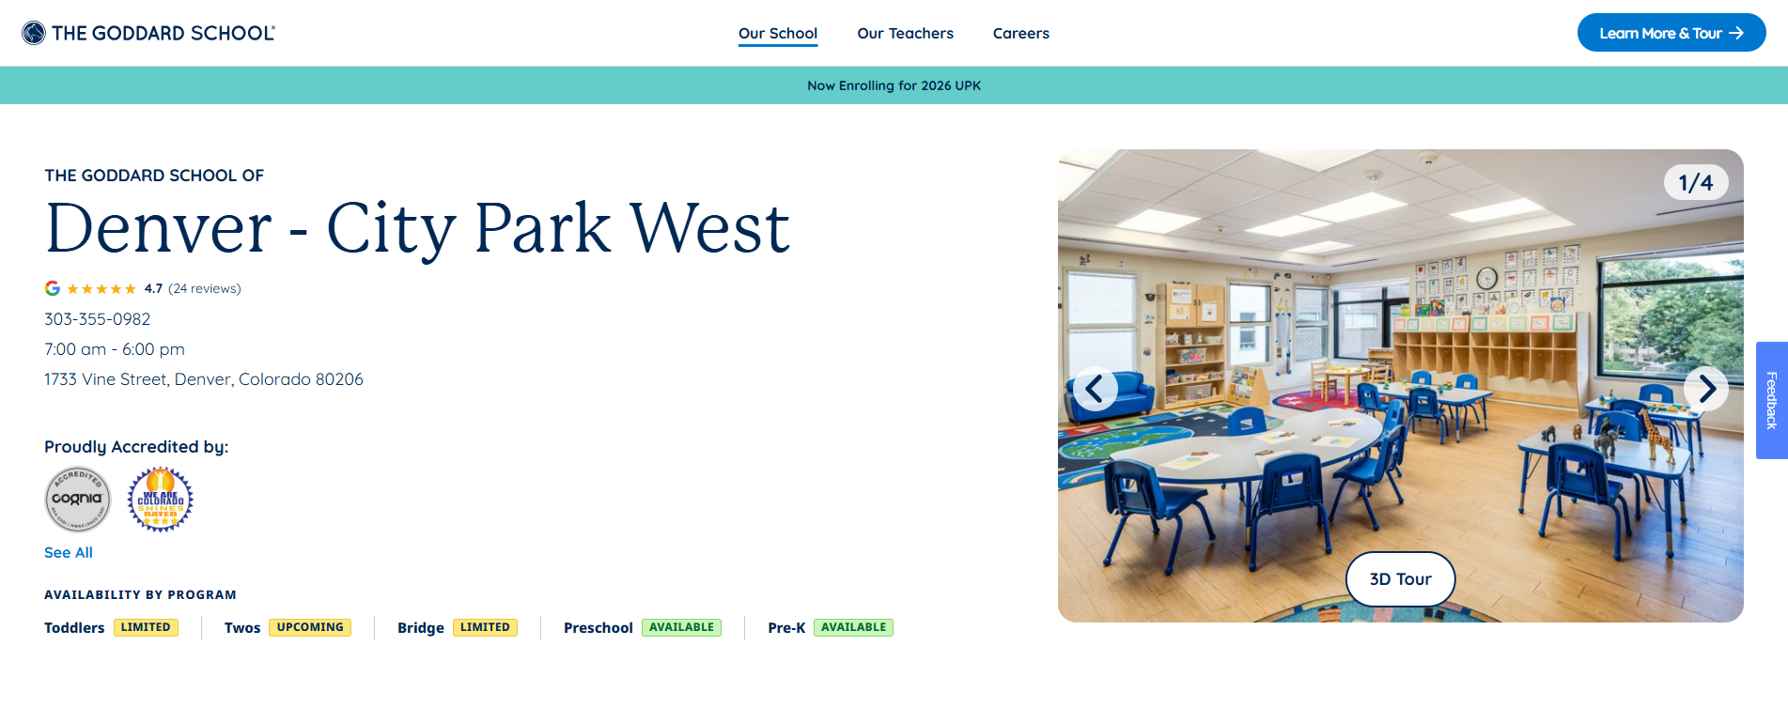

- Westminster: Link
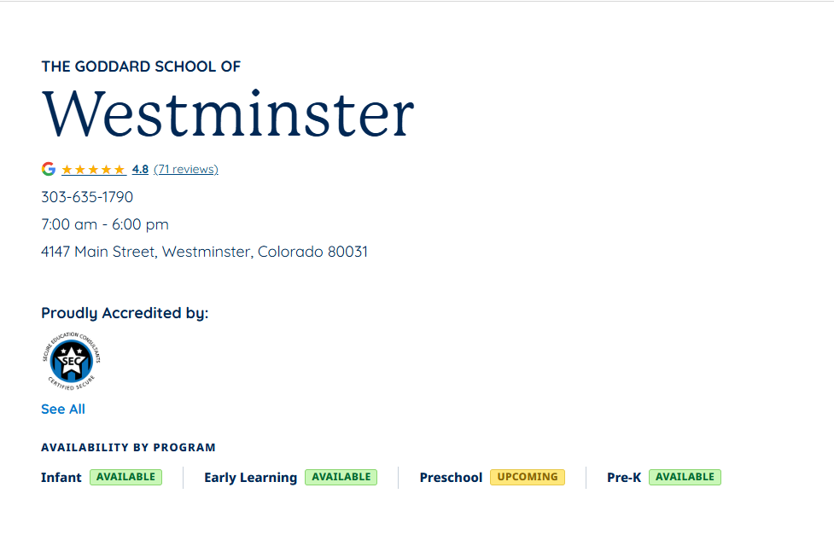
- Rockville (Desktop, mobile): Link
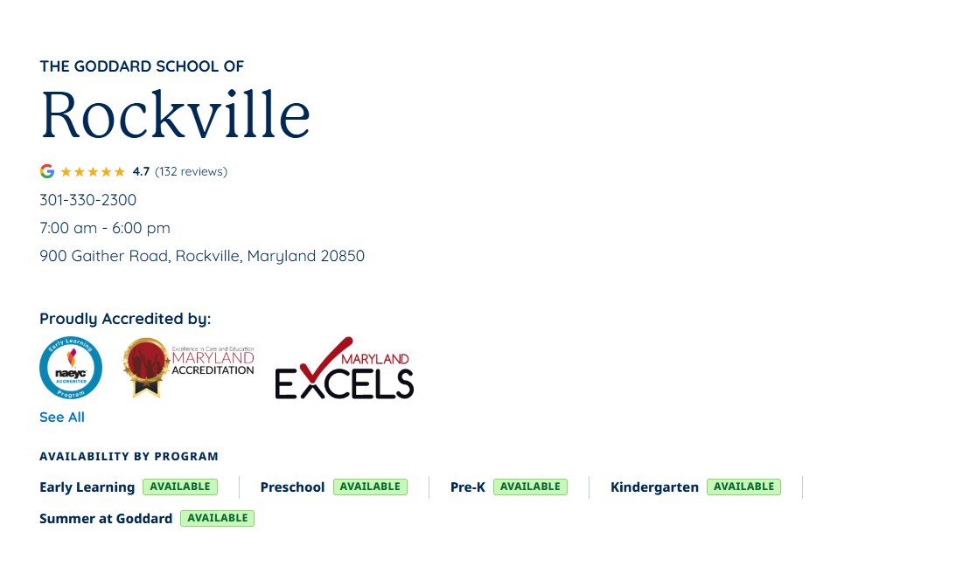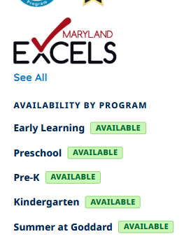
Qualifying
In a cache cleared Chrome browser, go to the following school pages:
- Park City West: Link
- Westminster: Link
- Rockville: Link
- Grand Rapids – Byron Center: Link
Or any school page with the adobe target preview param appended: ?at_preview_token=hAJCoU2tqB0Uev47DhVUC2Srwtp7JyznvKdleR8udUM&at_preview_index=1_2&at_preview_listed_activities_only=true&at_preview_evaluate_as_true_audience_ids=3823499
Here is how availability flags map to individual programs
Topics | Include | Flag Values
Infant | Infant | Match
Toddlers | Toddler, First Steps | Prioritize as follows: Available, limited, upcoming
Early Learning | Twos, Bridge, Get Set | Prioritize as follows: Available, limited, upcoming
Preschool | Preschool | Match
Pre-K | Pre K | Match

ADDITIONAL NOTES:
- When QA’ing across device types, please refresh the page around layout shifts
- Ensure values map appropriately to card values below:
  - If any of the grouped flags show different values, the experience prioritizes showing available, then limited, then upcoming

- Pages without availability flags in the cards should not be affected by the test (Ex: https://www.goddardschool.com/schools/co/englewood/meridian)

ANALYTICS QA:
- This code checks to see if 1+ flags exist. If 1+ flags exist, it will give you the count from the cards at the bottom, which may be different from the number at the top (done for consistency across control and variation)
(function () {
var selector = [
'.gsi-school-classroom-cards__availability.available',
'.gsi-school-classroom-cards__availability.limited',
'.gsi-school-classroom-cards__availability.upcoming'
].join(',');

var flags = Array.prototype.slice.call(document.querySelectorAll(selector));

var data = {
flagsFound: flags.length,
hasAvailable: false,
hasLimited: false,
hasUpcoming: false,
statuses: []
};

flags.forEach(function (flag) {
if (flag.classList.contains('available')) data.hasAvailable = true;
if (flag.classList.contains('limited')) data.hasLimited = true;
if (flag.classList.contains('upcoming')) data.hasUpcoming = true;
});

if (data.hasAvailable) data.statuses.push('available');
if (data.hasLimited) data.statuses.push('limited');
if (data.hasUpcoming) data.statuses.push('upcoming');

return data;
})();
- It will also give you the attributes that a user is seeing:
